**Movie Info Database Create:**

CREATE DATABASE movie_info;

**Director Table Create:**

CREATE TABLE director(

Person_ID INT(7) NOT NULL,

Director_Name VARCHAR(40) NOT NULL,

Birth_Year INT(4) NOT NULL,

No_Of_Films INT(4),

No_Of_Awards INT(4),

PRIMARY KEY(Person_ID)

);

**Data Insertion Director Table:**

INSERT INTO director VALUES

(1,'Zahir Raihan',1935,5,5),

(2,'Rajkumar Hirani',1962,5,9),

(3,'Saytajit Ray',1921,45,55),

(4,'Anjan Dutt',1953,23,17),

(5,'Rituparno Ghosh',1963,20,15),

(6,'Goutam Ghose',1950,12,8),

(7,'Aparna Sen',1945,12,7),

(8,'Kaushik Ganguly',1968,23,30);

**Actor Table Create:**

CREATE TABLE actor(

Person_ID INT(7) NOT NULL,

Actor_Name VARCHAR(40) NOT NULL,

Birth_Year INT(4) NOT NULL,

No_Of_Films INT(4),

No_Of_Awards INT(4),

PRIMARY KEY(Person_ID)

);

**Data Insertion Actor Table:**

INSERT INTO actor VALUES

(11,'Uttam Kumar',1926,190,150),

(12,'Razzak',1942,120,100),

(7,'Aparna Sen',1945,73,43),

(6,'Goutam Ghose',1950,3,1),

(8,'Kaushik Ganguly',1968,22,7),

(10,'Soumitra Chatterjee',1935,250,220),

(4,'Anjan Dutt',1953,39,10);

**Movie Table Create:**

CREATE TABLE movie(

Movie_ID INT(7),

Movie_Name VARCHAR(40),

Genre VARCHAR(20),

Year INT(4),

IMDB_Rating NUMERIC(4,2),

Person_ID INT(7),

PRIMARY KEY(Movie_ID),

FOREIGN KEY (Person_ID) REFERENCES director(Person_ID)

);

**Data Insertion Movie Table:**

INSERT INTO movie VALUES

(1,'Pather Panchali','Drama',1955,8.5,3),

(2,'Noukadubi','Drama',2011,7.6,5),

(3,'Abohomaan','Drama',2009,7.3,5),

(4,'Joi Baba Felunath','Thriller',1979,8.0,3),

(5,'Jibon Theke Neya','Drama',1970,9.4,1),

(6,'Moner Manush','Biography',2010,8.0,6),

(7,'Apur Panchali','Biography',2013,8.2,8),

(8,'Goynar Baksho','Comedy',2013,7.1,7),

(9,'Byomkesh O Agnibaan','Thriller',2017,7.4,4),

(10,'Byomkesh Bakshi','Thriller',2010,7.4,4),

(11,'PK','Fiction',2014,8.2,2);

**Query 1.1: Find the name, genre, and IMDB rating of all the movies**

**SELECT Movie_Name,Genre,IMDB_Rating from movie;**

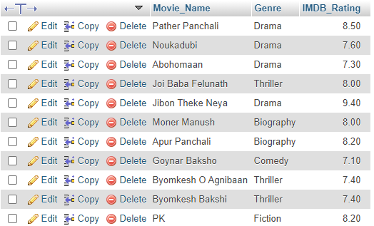

**Query 1.2: Display all the distinct movie-genres.**

**SELECT DISTINCT Genre from movie;**



**Query 1.3: Find the name and current age of all the actors.**

**SELECT Actor_Name,2021-Birth_Year AS Current_Age from actor;**

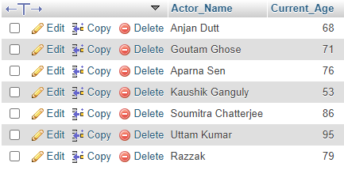

**Query 1.4: Find all the movies of the thriller genre with an IMDB rating greater than or equal to 8.0.**

**SELECT Movie_Name FROM movie WHERE (Genre='Thriller' AND IMDB_Rating>=8.0)**



**Query 1.5: Find the name, release year, IMDB rating, and the name of the director of all the movies**

**SELECT Movie_Name,Year,IMDB_Rating,director.Director_Name FROM movie**

**INNER JOIN director on movie.Person_ID=director.Person_ID;**

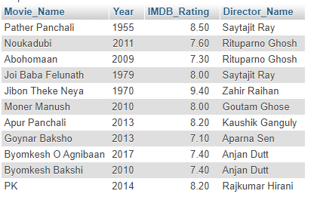

**Query 1.6: Find the name and number of awards of those directors whose name starts with an ‘S’**

**SELECT Director_Name,No_Of_Awards FROM director WHERE Director_Name LIKE 'S%';**



**Query 1.7: Find the name and birth year of those directors whose name contains an ‘a’ as its 2nd last character.**

**SELECT Director_Name,Birth_Year FROM director WHERE Director_Name LIKE '%a_';**

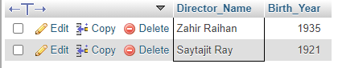

**Query 1.8: Find the name, release year, and genre of all the movies which contain the word ‘Byomkesh’ anywhere in their name**

**SELECT Movie_Name,Year,Genre from movie WHERE Movie_Name LIKE '%byomkesh%';**

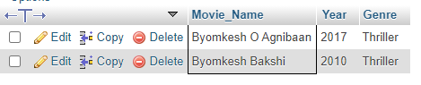

**Query 1.9: Find the name and IMDB rating of all the movies whose name consists of only 2 characters.**

**SELECT Movie_Name,IMDB_Rating FROM movie WHERE Movie_Name LIKE '__';**

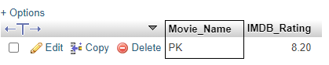

**Query 2.0: Find the name and genre of all the movies whose name consists of at least 4 characters.**

**SELECT Movie_Name,Genre from movie WHERE Movie_Name LIKE '____%';**

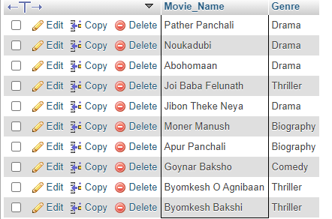

**Query 2.1: Find the name and IMDB rating of all the movies which contain either 1 or, 2 or, 3 or, 4 characters in their name.**

**SELECT Movie_Name,IMDB_Rating from movie WHERE Movie_Name NOT LIKE '_____%';**



**Query 2.2: Display all the movies according to their IMDB rating (in descending order); if multiple movies have the same IMDB rating then rearrange those movies alphabetically according to their names.**

**SELECT * from movie GROUP BY IMDB_Rating Desc,Movie_Name;**

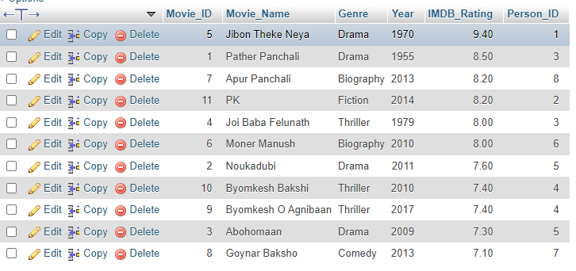

**Query 2.3: Find the average IMDB rating of all the movies of the drama genre.**

**SELECT Genre,AVG(IMDB_Rating) AS Average_IMDB_Rating FROM movie WHERE Genre='drama' GROUP BY Genre**



**Query 2.4: Find the total number of movies in the database.**

**SELECT COUNT(Movie_Name) AS Total_Movies from movie;**



**Query 2.5: Find how many movie-genres are there in the database.**

**SELECT COUNT(DISTINCT Genre) AS No_of_Movie_Genre FROM movie**



**Query 2.6: Find the total number of movies in each genre.**

**SELECT Genre,COUNT(Movie_Name) AS No_of_Movie from movie GROUP BY Genre;**

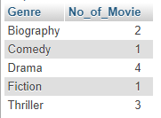

**Query 2.7: Find all the movies of action, thriller/fiction genre.**

**1.**

**SELECT Movie_Name,Genre from movie WHERE Genre='Action' OR Genre='Thriller' OR Genre='Fiction';**

**2.**

**SELECT Movie_Name,Genre from movie WHERE Genre IN ('Action', 'Thriller','Fiction')**

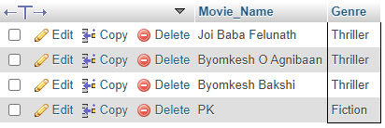

**Query 2.8: Find the Name and current age of all the directors and actors.**

**(SELECT Director_Name AS Name,2021-Birth_Year AS Current_Age FROM director) UNION (SELECT Actor_Name AS Name,2021-Birth_Year AS Current_Age from actor);**

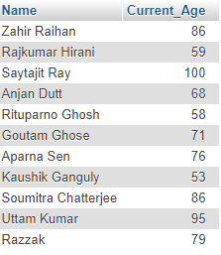

**Query 3.1 : Display the name, IMDb rating and genre of all the movies with an IMDB rating greater than or equal to 8.0.**

**SELECT Movie_Name, IMDB_Rating, Genre from movie WHERE IMDB_Rating >=8.0**

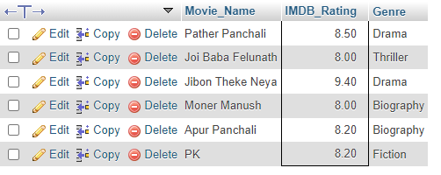

**Query 3.2 : Display all the distinct movie-genres and the average IMDb**

**rating of each movie-genre.**

**SELECT Genre , AVG(IMDB_Rating) FROM movie GROUP BY Genre**

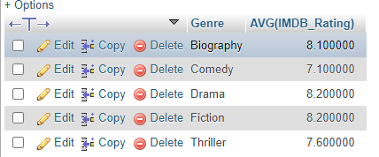

**Query 3.3 : Find the name and the average IMDb rating of those**

**movie-genres whose average IMDb rating is greater than or equal to 7.5.**

**SELECT Genre , AVG(IMDB_Rating) FROM movie GROUP BY GENRE HAVING AVG(IMDB_Rating)>=7.5 ;**

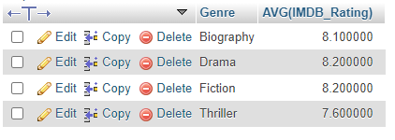

**Query 3.4 : Find the name, number of films and number of awards of the**

**director who directed the most number of films..**

**SELECT Director_Name, No_Of_Films, No_Of_Awards FROM director WHERE No_Of_Films = (SELECT MAX(No_Of_Films) FROM director)**

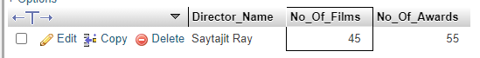

**Query 3.5 : Find the name, current age, number of films and number of**

**awards of the youngest actor.**

**SELECT Actor_Name, 2021-Birth_Year as Current_Age , No_Of_Films, No_Of_Awards from actor where Birth_Year= (SELECT MAX(Birth_Year) from actor)**



**Query 3.6 : Find the name, IMDb rating and genre of those movies whose**

**IMDb Rating is above average.**

**SELECT Movie_Name, IMDB_Rating, Genre FROM movie WHERE IMDB_Rating>(SELECT AVG(IMDB_Rating) FROM movie);**

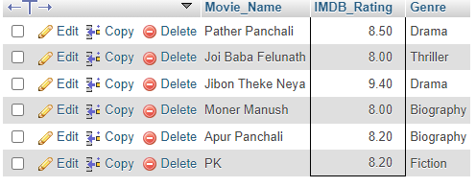

**Query 3.7 : Find the name and average IMDb rating of those movie-genres whose average IMDb rating is below average.**

**SELECT GENRE,AVG(IMDB_Rating) FROM MOVIE GROUP BY GENRE**

**HAVING AVG(IMDB_Rating)<**

**(SELECT AVG(AVG_IMDB) AS AVERAGE**

**FROM**

**(SELECT AVG(IMDB_Rating) as AVG_IMDB from movie GROUP BY Genre) AS GENRE_IMDB)**

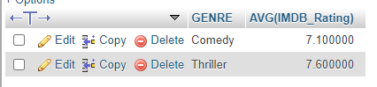

**Query 3.8 : Among all the movie genres, find the highest average IMDb rating.**

**(SELECT MAX(AVG_IMDB) AS MAX_AVG_IMDB FROM**

**(SELECT AVG(IMDB_Rating) AS AVG_IMDB FROM movie GROUP BY Genre) AS GENRE_IMDB)**



**Movie_Characters Table Create:**

CREATE TABLE movie_characters(

Character_ID INT(7) NOT NULL,

Character_Name VARCHAR(40) NOT NULL,

Age INT(3),

PRIMARY KEY(Character_ID)

**);**

**Data Insertion Movie_Characters Table**

INSERT INTO movie_characters VALUES

(1, 'Apu', 7),

(2, 'Durga',10),

(3, 'Harihar', 42),

(4, 'Sarbajaya', 35),

(5, 'Ramesh', 28),

(6, 'Hemnalini', 25),

(7, 'Nalinaksha', 30),

(8, 'Kamala', 20),

(9, 'Shikha', 21),

(10, 'Apratim', 26),

(11, 'Feluda', 25),

(12, 'Maganlal Meghraj', 35),

(13, 'Jatayu', 45),

(14, 'Topshe', 18),

(15, 'Ruku', 6),

(16, 'Faruk', 22),

(17, 'Bithi', 19),

(18, 'Sathi', 24),

(19, 'Lalon', null),

(20, 'Kaluah', 25),

(21, 'Siraj Saain', 45),

(22, 'Komli', 25),

(23, 'Subir Banerjee', null),

(24, 'Ashima', 24),

(25, 'Rashmoni', null),

(26, 'Somalata', 24),

(27, 'Chaitali', 18),

(28, 'Byomkesh Bakshi', 26),

(29, 'Ajit', 27),

(30, 'Malati', 16),

(31, 'Debkumar', 50),

(32, 'Doctor Anukul', 45),

(33, 'Prabhat', 27),

(34, 'Satyabati', 22),

(35, 'Anadi Babu', 55),

(36, 'PK', null),

(37, 'Jaggu', 26),

(38, 'Sarfaraz', 29),

(39, 'Tapasvi Maharaj', 50)

**Movie_Characters_Relationship Table Create:**

CREATE TABLE movie_characters_relationship

(

Character_ID INT(7) NOT NULL,

Movie_ID INT(7),

FOREIGN KEY (Character_ID) REFERENCES movie_characters(Character_ID),

FOREIGN KEY (Movie_ID) REFERENCES movie(Movie_ID)

);

**Data Insertion Movie_Characters_Relationship Table :**

INSERT INTO `movie_characters_relationship` VALUES

(1, 1),

(2, 1),

(3, 1),

(4, 1),

(5, 2),

(6, 2),

(7, 2),

(8, 2),

(9, 3),

(10, 3),

(11, 4),

(12, 4),

(13, 4),

(14, 4),

(15, 4),

(16, 5),

(17, 5),

(18, 5),

(19, 6),

(20, 6),

(21, 6),

(22, 6),

(23, 7),

(24, 7),

(25, 8),

(26, 8),

(27, 8),

(28, 9),

(28, 10),

(29, 9),

(29, 10),

(30, 9),

(31, 9),

(32, 9),

(33, 10),

(34, 9),

(34, 10),

(35, 10),

(36, 11),

(37, 11),

(38, 11),

(39, 11);

**Query 4.1 : Find the name and age of all the movie characters who are not teenagers.**

**SELECT Character_Name,Age FROM movie_characters**

**WHERE Age NOT BETWEEN 13 AND 19 OR AGE IS NULL**

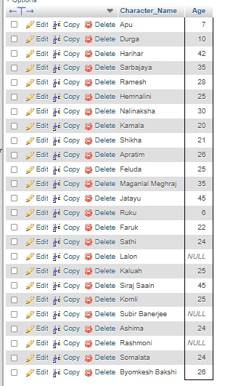

**Query 4.2 : Find the movie ID of all the movies and the number of**

**movie-characters in each movie.**

**SELECT Movie_ID,COUNT(Character_ID) AS Number_of_Characters FROM movie_characters_relationship GROUP BY Movie_ID;**

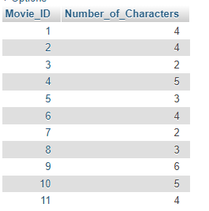

**Query 4.3 : Find the movie name of all the movies and the number of**

**movie-characters in each movie.**

**SELECT Movie_Name, COUNT(Character_ID) AS Number_of_Characters FROM movie JOIN movie_characters_relationship USING(Movie_ID) GROUP BY Movie_ID**

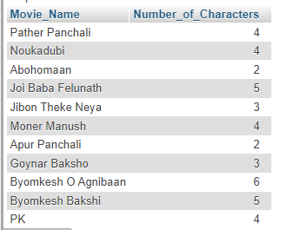

**Query 4.4: Find the name, year of release, IMDB rating and the name of the director of all the movies that contain at least 12 characters (including spaces) in their name.**

**SELECT Movie_Name, Year, IMDB_Rating, Director_Name FROM movie JOIN director USING(Person_ID) WHERE LENGTH(Movie_Name) >= 12**

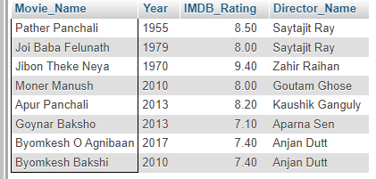

**Query 4.5: Find the name, year of release, IMDB rating and the name of the director of all the movies that contain at most 12 characters (including spaces) in their name.**

**SELECT Movie_Name, Year, IMDB_Rating, Director_Name FROM movie JOIN director USING(Person_ID) WHERE LENGTH(Movie_Name) <= 12**

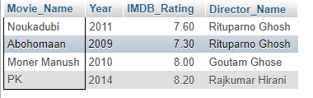

**Query 4.6: Find the name, year of release, IMDB rating of all the movies of Byomkesh (N.B.: A movie of Byomkesh may not contain the term ‘Byomkesh’ in its name).**

**SELECT Movie_Name, Year, IMDB_Rating FROM movie**

**WHERE Movie_ID IN**

**(SELECT Movie_ID FROM movie_characters_relationship JOIN movie_characters USING(Character_ID)**

**WHERE Character_Name = 'Byomkesh Bakshi')**

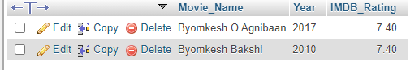

**Query 4.7: Find the name and age of all the characters from the movies of Feluda (N.B.: A movie of Feluda may not contain the term ‘Feluda’ in its name).**

**SELECT Character_Name, Age FROM movie_characters WHERE Character_ID IN**

**(SELECT Character_ID FROM movie_characters_relationship WHERE Movie_ID IN**

**(SELECT Movie_ID FROM movie_characters_relationship JOIN movie_characters USING(Character_ID) WHERE Character_Name='Feluda'))**

